**KS3 ‘The Ellowes’ Quiz 2: YEAR 8**

This is a quiz to determine your progress on learning the essential knowledge from your lessons, knowledge organisers and subjects.

**Question 1: English**

What is an omniscient narrator? [Pick one]

1. A narrator who just follows one character and their thoughts and events in the story.
2. An all-knowing narrator who knows all events and thoughts of every character in the story.
3. A narrator who is one of the main characters in the story.
4. When a story switches between two narrators so you get two different points of view.

**Question 2: Maths**

Which of the following is the definition of factor? [Pick one]

1. Number that divide into another number with no remainder
2. Times table of a number
3. Numbers that can only be divided by themselves and 1
4. Numbers which times into another number with no remainder

**Question 3: Science**

The diagram shows part of the lungs. [Pick one]

What are the gases X and Y?

1. X = oxygen Y = carbon dioxide.
2. X = carbon dioxide Y = oxygen.
3. X = air Y = carbon dioxide
4. X = air Y = Nitrogen.

**Question 4: History**

Which of these sequence of events is in the correct chronological order? [Pick one]

1. Death of King John, Battle of Hastings, Battle of Stanford Bridge, Domesday Book
2. Death of King John, Battle of Stanford Bridge, Battle of Hastings, Domesday Book
3. Battle of Stanford Bridge, Battle of Hastings, Domesday Book, Death of King John
4. Death of King John, Domesday Book, Battle of Stanford Bridge, Battle of Hastings

**Question 5: Geography**

Which statement best describes the upper course of the river? [Pick one]

1. Flat gradient, Fast flowing water, very deep and wide
2. Steep gradient, slow flowing water, shallow and narrow channel
3. Gentle gradient, faster velocity, wide, deep channel
4. Flat gradient, slow flowing water, deep channel

**Question 6: English**

The resolution or conclusion to a story when the plot reaches its final outcome is known as the…? [Pick one]

1. Climax
2. Falling action
3. Denouement
4. Rising Action

**Question 7: Maths**

Pick the correct answer to the question 10 – 4 x 2 [Pick one]

1. 12
2. 2
3. -2
4. 16

**Question 8: Science**

Air we breathe in contains: [Pick one]

|  |  |  |  |
| --- | --- | --- | --- |
|  | Nitrogen % | Oxygen % | Carbon dioxide % |
| A | 0 | 0 | 100 |
| B | 78 | 21 | 0.04 |
| C | 0.04 | 21 | 78 |
| D | 0 | 100 | 0 |

**Question 9: History**

What items are labelled on this Roman Centurian? [Pick one]

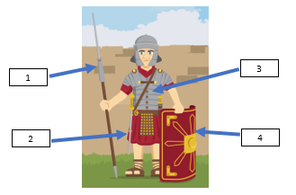

1. 1 – Pilum 2 – Gladius 3- Lorica Segmentata 4 - Scutum
2. 1 – Scutum 2 – Gladius 3 – Lorica Segmentata 4 - Pilum
3. 1 – Pilum 2 – Gladius 3 – Scutum 4- Lorica Segmentata
4. 1 – Gladius 2- Scutum 3 – Pilum 4 – Lorica Segmentata

**Question 10: Geography**

Which type of erosion is the force of the water removing material from the bed and sides of the river channel? [Pick one]

1. Abrasion
2. Hydraulic Action
3. Attrition
4. Solution

**Question 11: English**

Which of the following are conventions (feature) of a letter [Pick two]

1. The recipient’s address at the top left with the sender’s address underneath it on the right.
2. Starts with Dear…
3. Signed off with ‘yours sincerely’ or ‘yours faithfully’
4. The date underneath the sender’s address.

**Question 12: Maths**

Which of the following is a triangular number? [Pick one]

1. 16
2. 6
3. 8
4. 2

**Question 13: Science**

Which the correct order of size? [Pick one]

1. cell atom tissue
2. atom cell tissue
3. tissue atom cell
4. tissue cell atom

**Question 14: History**

What punishment did women receive for gossiping? [Pick one]

1. Scolds Bridal
2. Hanging
3. Hood of Shame
4. Fine

**Question 15: Geography**

Which type of erosion is the chemical process in which the weak acids contained in the river dissolve the rocks and soil of the river’s bed and banks? [Pick one]

1. Abrasion
2. Hydraulic Action
3. Attrition
4. Solution

**Question 16: English**

If a story is written in chronological order, what does this mean? [Pick one]

1. Events are described in the order in which they happen.
2. Events aren’t written in time order.
3. The story has a flashback.
4. The story moves between the past and present, alternating in each chapter.

**Question 17: Maths**

Pick two that are common factors of 12 and 18 [Pick two]

1. 12
2. 48
3. 6
4. 3

**Question 18: Science**

Which of these is an organ? [Pick one]

1. Muscles
2. Cell
3. Sperm
4. Heart

**Question 19: History**

Which of the following were involved in the Gunpowder Plot? [Pick one]

1. Guy Fawkes and James Stewart
2. Guy Fawkes and John Catesby
3. Guy Fawkes and Robert Catesby
4. Guy Fawkes and Robert Stewart

**Question 20: Geography**

Waterfalls are found in the: [Pick one]

1. Upper course
2. Middle course
3. Lower course
4. Any course

**Question 21: English**

What could the train be a symbol for in The Train From Rhodesia? [Pick two]

1. New ways of travelling around South Africa that is more comfortable.
2. A visual hierarchy to show those who have wealth, power and opportunity and those who don’t.
3. The inability of the poor to be able to leave the cycle of poverty in which they live.
4. A new beginning for the poor as they can leave their village.

**Question 22: Maths**

What is the name of this symbol ? [Pick one]

1. Cubed root
2. Square
3. Square root
4. Cube

**Question 23: Science**

Niall decides to remove most fat from his diet.

Which statement is correct?

1. He will be healthier as he will be fitter.
2. He will be less healthy as the body needs lots of fat.
3. He will be healthier as fat is bad for your heart.
4. His health won’t change as he can get energy from sugar.

**Question 24: History**

What religion were the Gunpowder plotters [Pick one]

1. Catholic
2. Protestant
3. Puritan
4. Mormon

**Question 25: Geography**

The source of the river is… [Pick one]

1. An imaginary line that separates 2 drainage basins
2. Where the river ends its journey and flows into either a lake, the sea or the ocean
3. Where the river begins, its starting point
4. Flat land on either side of the river that gets submerged when the river floods

**Question 26: English**

Oppression is…. [Pick one]

1. Prolonged kindness from others.
2. One occasion in which someone is treated kindly.
3. Prolonged cruel or unjust treatment.
4. One occasion in which someone is treated cruelly or unjustly.

**Question 27: Maths**

What is 36.548 rounded to 1 decimal place? [Pick one]

1. 36.6
2. 36.5
3. 36.500
4. 36.4

**Question 28: Science**

The labels on the diagram show parts of the digestive system. [Pick one]



Which part(s) digest food?

1. Just X
2. Just Y
3. X and Y
4. X, Y and Z

**Question 29: History**

Which is the correct order for the Feudal System [Pick one]

1. King, Nobles, Knights, Peasants
2. King, Knights, Peasants, Nobles
3. King, Peasants, Nobles, Knights
4. King, Knights, Nobles, Peasants

**Question 30: Geography**

A flood plain is…. [Pick one]

1. An imaginary line that separates 2 drainage basins
2. Where the river ends its journey and flows into either a lake, the sea or the ocean
3. Where the river begins, its starting point
4. Flat land on either side of the river that gets submerged when the river floods

**Question 31: English**

Social mobility is…. [Pick one]

1. Movement of individuals, families or groups through a social hierarchy.
2. Remaining in the same place within a social hierarchy for a long period of time.
3. Gaining money very quickly from one source.
4. Losing all money and facing bankruptcy.

**Question 32: Maths**

What is a suitable estimate to 34 x 624? [Pick one]

1. 18000
2. 1800
3. 24000
4. 240

**Question 33: Science**

Zane added a powder to a liquid. [Pick one]

Which observation indicates there was a chemical change?

1. The Powder Dissolved.
2. The powder melted 2 g/cm3.
3. The mass of the liquid increased.
4. The liquid bubbled.

**Question 34: History**

What was the name of the Pope that started the first Crusade [Pick one]

1. Gregory IV
2. Urban II
3. Innocent I
4. Urban III

**Question 35: Geography**

A small river that joins a larger river is called [Pick one]

1. Confluence
2. Tributary
3. Watershed
4. Drainage Basin

**Question 36: English**

Disparity is… [Pick one]

1. A clear similarity.
2. A great difference.
3. When someone has no opinion, so neither agrees or disagrees.
4. When something is equal.

**Question 37: Maths**

What does the word denominator mean? [Pick one]

1. The top number on a fraction
2. To divide a fraction
3. The whole number in front of a mixed fraction
4. The bottom number on a fraction

**Question 38: Science**

What is the pH of the stomach? [Pick one]

1. 2-4
2. 5-6
3. 7
4. 7-8

**Question 39: History**

Which of these can be defined as knowing the difference between right and wrong [Pick one]

1. Crime
2. Consequence
3. Morality
4. Ordeal

**Question 40: Geography**

What is the four-figure grid reference for the telephone box [Pick one]

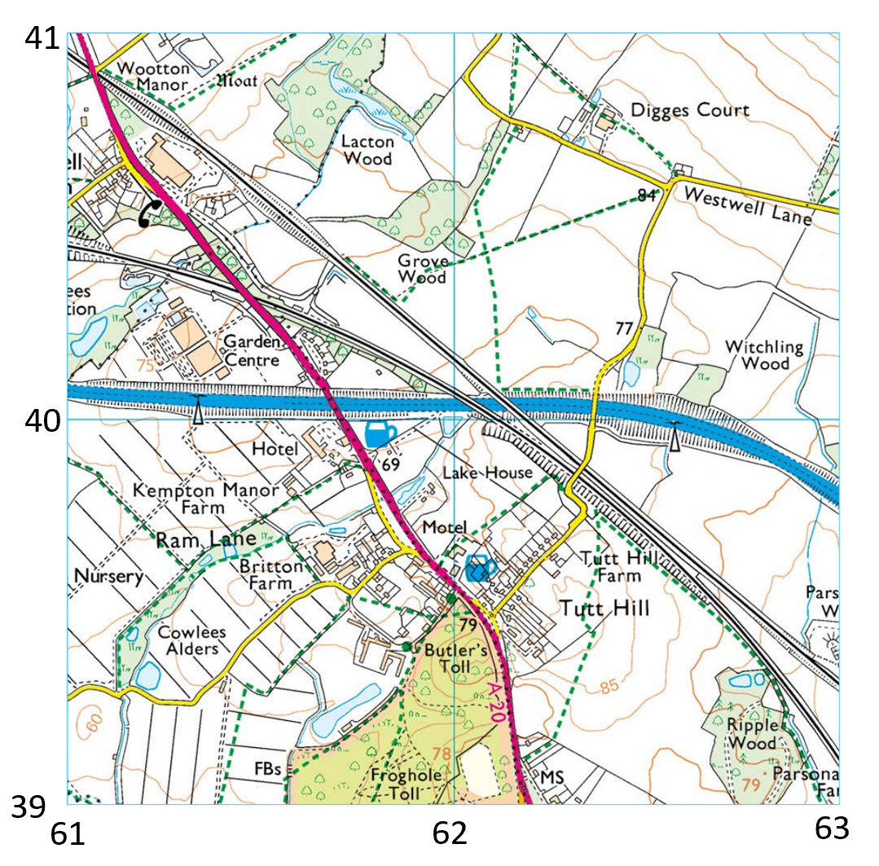

1. 6140
2. 6240
3. 6141
4. 6340

**Question 41: English**

What is colonialism? [Pick one]

1. When a country chooses to give its natural resources to another country.
2. When a country gains freedom from another country.
3. When a country gains authority over people with the aim of political and economic control.
4. When a country borrows money from another country.

**Question 42: Maths**

What is the name of this symbol >? [Pick one]

1. Less than or equal to
2. Greater than
3. Great than or equal to
4. Less than

**Question 43: Science**

A tug of war team is pulled by a rope. The team does not move.

What is the force of friction on the team? [Pick one]

1. 0 N
2. More than 1200 N
3. 1200N.
4. Less than 1200N

**Question 44: History**

In what type of environment did the Jack the Ripper murders take place [Pick one]

1. 20th Century City
2. 20th Century Countryside
3. 19th Century City
4. 19th Century Countryside

**Question 45: Geography**

Which key term is the point where two rivers meet [Pick one]

1. Tributary
2. Floodplain
3. Confluence
4. Watershed

**Question 46: English**

Which of the following were reasons that colonialism was justified by Europeans? [Pick three]

1. They believed they had a religious obligation.
2. They believed that it was their duty as they were more ‘superior’.
3. They believed that they had to make the ‘savage’ more ‘civilised’.
4. They believed it would help them learn about other cultures.

**Question 47: Maths**

Pick two words that also mean to add two number [Pick two]

1. Sum
2. Difference
3. Share
4. Total

**Question 48: Science**

An iron block is carried on a spaceship beyond the atmosphere to 100 km above Earth.

What happens to the gravitational force on the block? [Pick one]

1. The force decreases a little.
2. The force remains the same.
3. The force decreases to nearly zero
4. The force decreases to zero

**Question 49: History**

What was the most important part of the Holy Land to Christians and Muslims [Pick one]

1. Antioch
2. Constantinople
3. Edessa
4. Jerusalem

**Question 50: Geography**

A watershed is…. [Pick one]

1. An imaginary line that separates 2 drainage basins
2. The point where two rivers meet
3. A small river that joins another
4. Where the river ends and meets the sea or lake